**Question:**

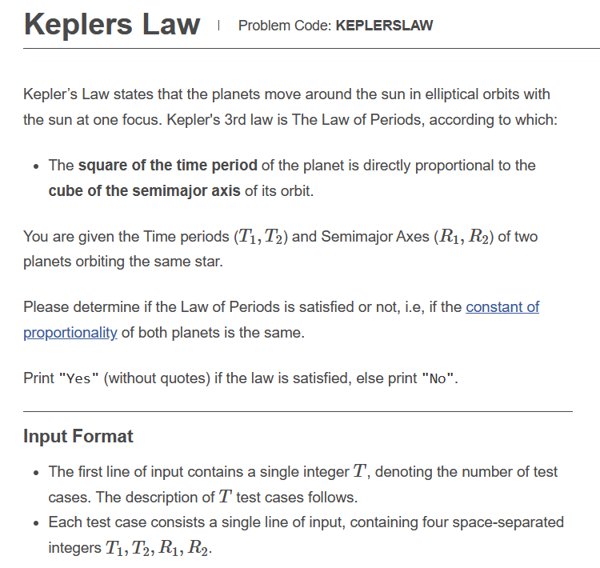

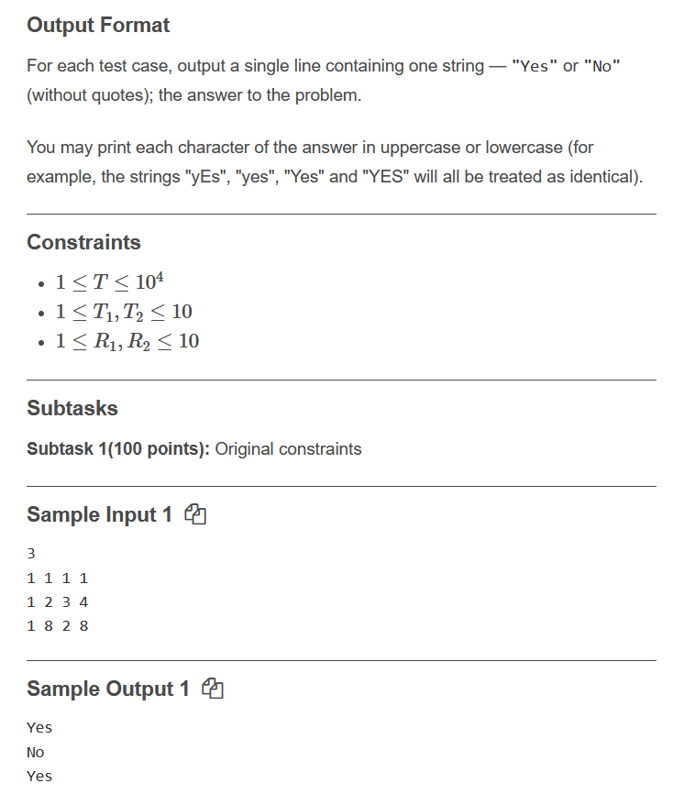

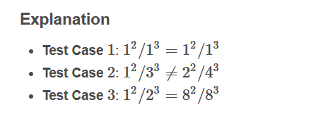

**Link:** [**https://www.codechef.com/JAN221C/problems/KEPLERSLAW**](https://www.codechef.com/JAN221C/problems/KEPLERSLAW)

**Code:**

**#include <iostream>**

**using namespace std;**

**int main() {**

**int n;**

**cin>>n;**

**double a,b,c,d;**

**for(int i=0;i<n;i++)**

**{**

**cin>>a;**

**cin>>b;**

**cin>>c;**

**cin>>d;**

**double e=(a*a)/(c*c*c);**

**double f=(b*b)/(d*d*d);**

**if(e==f)**

**{**

**cout<<"yes";**

**}**

**else{**

**cout<<"no";**

**}**

**cout<<endl;**

**}**

**return 0;**

**}**

**Solution: Correct(100 points)**